**REAL TIME PATIENT MONITORING AND TRACKING SYSTEM**

**A Project Report**

**Submitted by**

NAVEEN PRAKESH. G

INIYAN. S. K

KALAIVANAN. B

VISHAL. A

SANTHOSH. S

**BACHELOR OF ENGINEERING**

**in**

**ELECTRONICS AND COMMUNICATION ENGINEERING**



**VELAMMAL ENGINEERING COLLEGE (AUTONOMUS),**

**CHENNAI-66**



ANNA UNIVERSITY :: CHENNAI 600 025

EVEN SEM 2023-24

APPENDIX 2

**VELAMMAL ENGINEERING COLLEGE: CHENNAI-600066**

# BONAFIDE CERTIFICATE

Certified that this project report“**REAL TIME PATIENT HEALTH TRACKING AND MONITORING SYSTEM**” is the Bonafide work of **Naveen Prakash. G, Iniyan. S. K, Kalaivanan. B, Vishal. A, Santhosh. S**; who carried out the project work under my supervision.

|  |  |
| --- | --- |
| **Dr. P. PONSUDHA AP(III)** | **Dr. S. MARY JONES** |
| Supervisor  Department of Electronics and Communication Engineering  Velammal Engineering College  Chennai-66 | Professor & Head  Department of Electronics and Communication Engineering  Velammal Engineering College  Chennai-66 |

# TABEL OF CONTENT

|  |  |  |
| --- | --- | --- |
| **S.NO** | **CONTENT** | **PAGE NO** |
| 1 | ABSTRACT | 4 |
| 2 | OBJECTIVE | 5 |
| 3 | LITERATURE SURVEY | 6 |
| 4 | BLOCK DIAGRAM | 7 |
| 5 | HARDWARE DETAILS | 8 |
| 6 | SOFTWARE DETAILS | 8 |
| 7 | DESCRIPTION | 8 |
| 8 | CIRCUIT DIAGRAM | 9 |
| 9 | APPLICATIONS | 9 |
| 10 | BENIFITS | 10 |
| 11 | CIRCUIT OUTCOME | 11 |
| 12 | ARDUINO CODE | 12 |
| 13 | REFERENCES | 14 |
| 14 | OUTCOME OF THE PROJECT | 15 |

**ABSTRACT**

With the increasing demand for remote patient monitoring and the need for accurate temperature tracking, the integration of advanced sensors and IoT technologies has become imperative in healthcare systems. This abstract presents a patient temperature monitoring system employing the MLX90614 infrared thermometer sensor and NodeMCU microcontroller for efficient and real-time temperature monitoring. The MLX90614 sensor is a non-contact infrared temperature sensor capable of providing accurate temperature readings without physical contact. Its ability to measure temperatures without skin contact makes it ideal for healthcare applications where hygiene and patient comfort are paramount. The NodeMCU microcontroller, based on the ESP8266 Wi-Fi module, facilitates seamless data transmission and connectivity to the internet.The proposed system offers several advantages over traditional temperature monitoring methods. Firstly, it eliminates the need for physical contact with patients, reducing the risk of cross-contamination and infections. Secondly, the integration of NodeMCU enables real-time data transmission to a centralized server or cloud platform, allowing healthcare professionals to monitor patients' temperatures remotely. Moreover, the system can generate alerts in case of abnormal temperature readings, enabling timely intervention and patient care. The implementation of the system involves interfacing the MLX90614 sensor with the NodeMCU microcontroller, which processes the temperature data and transmits it wirelessly over the internet. The data can be accessed through a web interface or a dedicated application, providing healthcare providers with access to critical patient information anytime, anywhere.

**OBJECTIVE:**

The primary objective of the Patient Temperature Monitoring System is to provide a robust and real-time solution for continuous temperature surveillance in healthcare settings. This system aims to:

1. **Accurate Monitoring:** Ensure precise and reliable measurement of patients' body temperatures through advanced sensor technologies.
2. **Timely Notifications**: Implement a notification system to alert healthcare professionals or caregivers promptly in case of abnormal temperature fluctuations.
3. **Remote Accessibility:** Enable healthcare providers to access patient temperature data remotely, facilitating efficient monitoring and intervention.
4. **User-Friendly Interface:** Develop an intuitive interface for easy integration into healthcare workflows, ensuring seamless usage by medical personnel.
5. **Enhanced Patient Care:** Contribute to proactive healthcare by allowing timely responses to temperature variations, ultimately improving patient care outcomes.

**LITERATURE SURVEY:**

The literature surrounding patient temperature monitoring systems reveals a growing interest in leveraging technological advancements for enhanced healthcare. Key themes and findings from existing studies include:

The current market is moving toward wireless technology due to its convenience compared to wired-based systems [1]. This section will review existing methods for designing wireless temperature monitoring systems. Reference [2] discusses the application of temperature data acquisition and monitoring for a sensor network using ZigBee. This work uses a thermocouple as a sensor input, where it is connected to a cold junction compensator amplifier. After passing through an amplifier, the signal is fed into an analog to-digital converter (ADC) port at the ZigBee module. The temperature data will be transmitted using Zigbee protocol to a personal computer (PC) at a rate of four samplings per sec. A wireless sensor network for health monitoring is discussed in [3]. This system uses a network and its subsystems to transmit data to the base server before transmitting it to a PDA or personal computer. [4] discusses remote monitoring for agriculture using a wireless sensor and short message service (SMS). This system sends SMS messages to the farmer when the farm’s temperature is either too high or too low. The objective of [5] is to design a health monitoring system for a wireless body area network (WBAN). In this project, ActiS sensors are used to monitor a heart rate signal before transmitting the signal to a personal server through a wireless local area network (WAN). The wireless temperature monitoring system discussed in [6] uses an active RFID-based system to collect data from locations worldwide. In this project, the sensor detects the temperature and triggers the alarm when the temperature is too high or too low and sends the data wirelessly to the main server. While most of these devices have high data acquisition rates, they are expensive. In this work, a low cost temperature sensor transmitter and receiver were built. To prevent data loss during transmission, bit checking method was implemented to ensure high measurement accuracy.

**BLOCK DIAGRAM:**

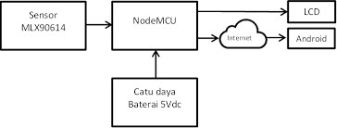

FIG 1:REAL TIME MONITORING

**HADWARE DETAILS:**

|  |  |  |
| --- | --- | --- |
| **S.NO** | **COMPONENTS** | **COST** |
| 1 | MLX90614 | 1100 |
| 2 | Node-MCU-ESP-8266 | 170 |

**SOFTWARE DETAILS:**

**Arduino Software IDE**

**DESCRIPTION:**

The Patient Temperature Monitoring System is a comprehensive healthcare solution designed to continuously and accurately monitor patients' body temperatures. Leveraging advanced sensor technologies, the system ensures precise temperature readings while prioritizing patient comfort and minimizing intrusion.

In summary, the Patient Temperature Monitoring System represents a sophisticated healthcare solution that prioritizes accuracy, user-friendliness, and security. By combining advanced sensor technologies with wireless connectivity and intelligent alert systems, the system aims to revolutionize patient temperature monitoring, contributing to proactive healthcare management and improved patient outcomes.

**CIRCUIT DIAGRAM:**

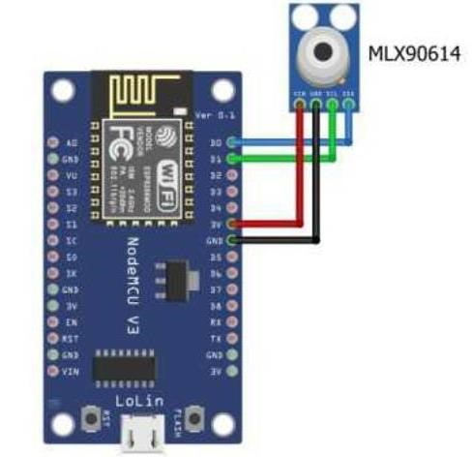

FIG 2:CIRCUIT DIAGRAM FOR NANOMCU & MLX90614

**APPLICATIONS:**

* A patient temperature monitoring system has various applications in healthcare settings.
* It aids in early detection of fever or abnormal temperature fluctuations, facilitating timely intervention.
* This system is crucial in hospitals, clinics, and home healthcare to monitor patients, especially those with infectious diseases, post-surgery, or chronic conditions.
* Additionally, it supports continuous remote monitoring, enhancing the efficiency of healthcare delivery and improving patient outcomes.

**BENEFITS:**

1.Early Detection

2.Improved Patient Care

3.Reduced Infection Spread

4.Remote Monitoring

5.Efficient Resource Utilization

6.Enhanced Recovery

7.Data analysis

8.Patient Comfort

9.Streamlined Workflow

10.Cost-Efficiency

**CIRCUIT OUTCOMES:**

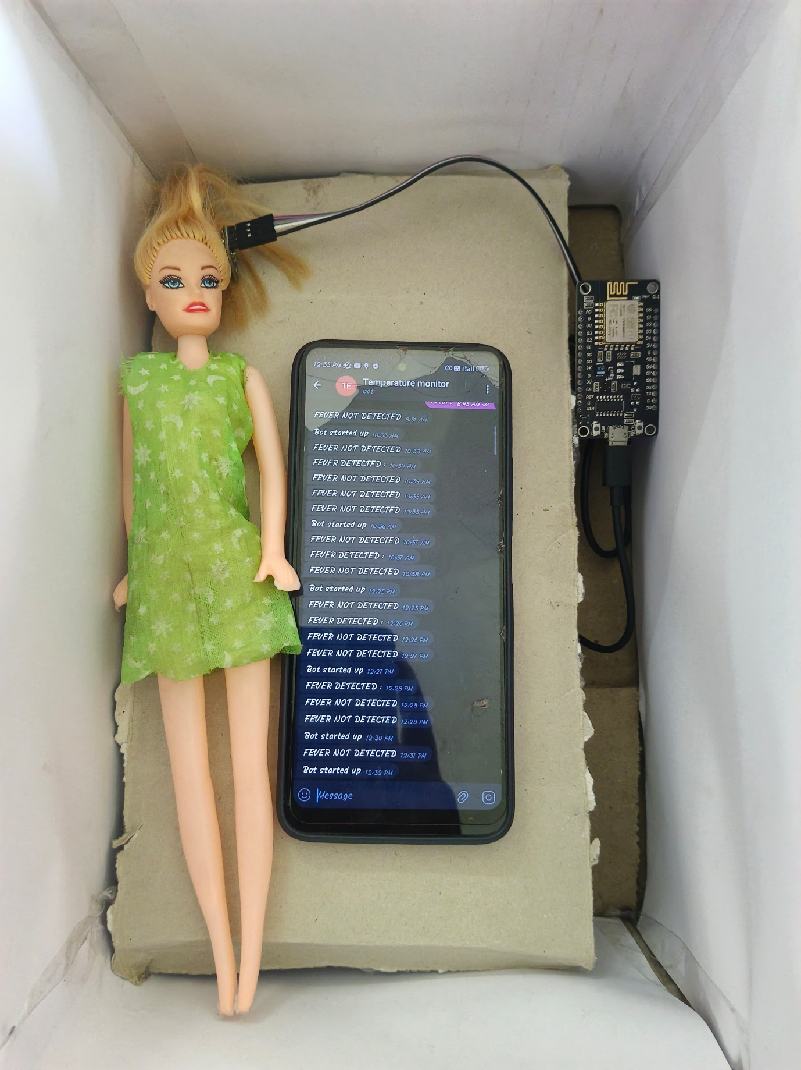

FIG 3: MODAL OF PATIENT TEMPERATURE MONITORING

**ARDUINO CODE:**

#include <Wire.h>

#include <Adafruit_MLX90614.h>

Adafruit_MLX90614 mlx = Adafruit_MLX90614();

#include <ESP8266WiFi.h>

#include <WiFiClientSecure.h> // Using Node MCU ESP8266 Library.

#include <UniversalTelegramBot.h> // including the library of Telegram Bot

#include <ArduinoJson.h> // Using JSON Library.

const char* ssid = "ethukku intha vela"; //WIFI Name.

const char* password = "naveen 74"; //WIFI Password.

#define BOTtoken "6645523122:AAF79rT7VMqJ1FmYqXo3NkeW1MdxHgl2xps" // your Bot Token (Get from Botfather)

#define CHAT_ID "1877980506" // Your bot ID.

WiFiClientSecure client;

UniversalTelegramBot bot(BOTtoken, client);

void setup() {

Serial.begin(115200);

while (!Serial);

if (!mlx.begin()) {

Serial.println("Error connecting to MLX sensor. Check wiring.");

while (1);

};

client.setInsecure();

// Attempt to connect to Wifi network:

Serial.print("Connecting Wifi: ");

//Display SSID

Serial.println(ssid); // Display SSID

WiFi.mode(WIFI_STA);

WiFi.begin(ssid, password); //Start WIFI.

while (WiFi.status() != WL_CONNECTED) {

Serial.print(".");

delay(5);

}

Serial.println("");

Serial.println("WiFi connected");

Serial.print("IP address: ");

Serial.println(WiFi.localIP());

//Send message to Telegram for program start up.

bot.sendMessage(CHAT_ID, "Bot started up", "");

}

void loop() {

Serial.print("Ambient = "); Serial.print(mlx.readAmbientTempC());

Serial.print("*C\tObject = "); Serial.print(mlx.readObjectTempC()); Serial.println("*C");

Serial.print("Ambient = "); Serial.print(mlx.readAmbientTempF());

Serial.print("*F\tObject = "); Serial.print(mlx.readObjectTempF()); Serial.println("*F");

Serial.println();

//delay(500);

if (mlx.readObjectTempF() >= 100) {

bot.sendMessage(CHAT_ID, "FEVER DETECTED : ", "");

Serial.println("FEVER DETECTED");

//bot.sendMessage(CHAT_ID, analogSensor);

}

else {

bot.sendMessage(CHAT_ID, "FEVER NOT DETECTED");

//bot.sendMessage(CHAT_ID, analogSensor);

Serial.println("FEVER NOT DETECTED");

}

//If String value is Greater Than or Equal to 25

//delay(20);

{

**REFERENCES:**

[1]George W. Irwin, Jeremy Colandairaj and William G. Scanlon, “An

Overview of Wireless Networks in Control and Monitoring,” International Conference on Intelligent Computing (CHINE 2006), Vol. 4114, pp. 1061-1072, 2006.

[2] Cai Bin, Jin Xinchao, Yan Shaomin; Yang Jianxu; Zhao Xibin; Zou

Guowei; “ Application research on temperature WSN nodes in switchgear assemblies based on TinyOS and ZigBee,” 4th International Conference on Electric Utility Deregulation and Restructuring and

Power Technologies (DRPT), 201, pp: 535 – 538, 2011

[3] G. Virone, A. Wood, L. Selavo, Q. Cao, L. Fang, T. Doan, Z. He, R. Stoleru, S. Lin, and J. A. Stankovic, “An Advanced Wireless Sensor

Network for Health Monitoring,” Transdisciplinary Conference on Distributed Diagnosis and Home Healthcare (D2H2), April 2-4, 2006.

[4] Zhang Zuojing; Zhang Haihui; "Design of Wireless Monitoring and

Warning System for Protected Agriculture Environment," 6th International Conference on Wireless Communications Networking and Mobile Computing (WiCOM), pg: 1 – 5, 2010.

[5] Emil Jovanov, Aleksandar Milenkovic, Chris Otto and Piet C de Groen, "A wireless body area network of intelligent motion sensors for computer assisted physical rehabilitation," Journal of NeuroEngineering and Rehabilitation, pp: 2:6, 2005.

[6] Namjun Cho; Seong-Jun Song; Sunyoung Kim; Shiho Kim; Hoi-Jun Yoo, "A 5.1-μW UHF RFID tag chip integrated with sensors for wireless environmental monitoring," Proceedings of the 31st European Solid-State Circuits Conference ( ESSCIRC), pp: 279 – 282, 2005.

**CONCLUSION**

The proposed patient temperature monitoring system offers a reliable, non-invasive, and efficient solution for continuous temperature monitoring in healthcare settings. By leveraging the MLX90614 sensor and NodeMCU microcontroller, the system provides accurate temperature readings and real-time data transmission, contributing to enhanced patient care and monitoring capabilities in modern healthcare facilities.

**OUTCOME OF THE PROJECT**

Implementing a patient temperature monitoring system is crucial for timely detection of abnormalities, enhancing patient care, and preventing potential health complications. This technology not only ensures real-time tracking but also streamlines healthcare processes, promoting overall efficiency and improved outcomes for patients.